Production of Eastern Bluebirds in Monitored Houses

Annual Report - 2004

Brice Prairie Conservation Association

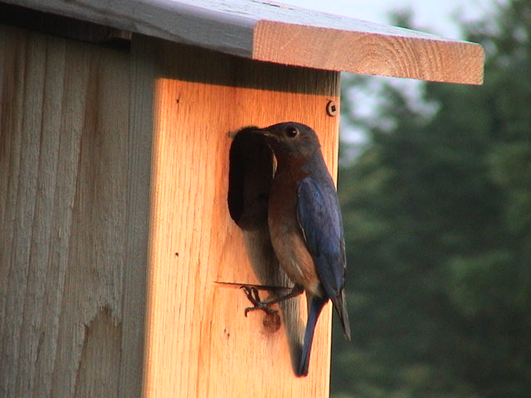

By

Leif L. Marking, Project Manager

W7917 CTH ZB
Onalaska, Wisconsin 54650
cmarking@centurytel.net
(608) 781-0323

Production of Eastern Bluebirds in Monitored Houses

Summary of Results for 2004

Bluebirds are cavity nesting song birds that are unable to create their own nesting cavities. Natural cavity availability declined significantly when non-native House Sparrows and European Starlings were introduced to this country over 150 years ago because they were victorious competitors for nest cavities and vicious predators of bluebird eggs and young. However, bluebird populations have been increasing since the birth of the North American Bluebird Society (NABS) in 1978 followed by many state chapters. Our Brice Prairie Conservation Association (BPCA) members have selected the NABS-style house to promote bluebird production because the design is so practical, they are easy to construct, and bluebirds readily occupy them (http://www.nabluebirdsociety.org/e_wbox2.htm). We mount these cedar houses on a steel T-type fence post that is covered with a 5 ft. section of PVC pipe (1 ½”) for mammalian predator control. The houses are placed 200 yards or more apart to respect the territorial nature of bluebirds and to encourage maximum production of bluebirds. Site and habitat selection favors bluebird ecology with large, open, grazed or mowed spaces where bluebirds forage for insects. Weekly observations are recorded in notebooks of choice, and these results are transferred to spread sheet summaries for calculations, evaluations, and presentations see website (http://www.briceprairieconservation.org/).

The BPCA goal was to produce 2,500 fledgling Eastern Bluebirds in 2004 after recording 2,001 in 2003. We exceeded our goal appreciably by recording 3,066 bluebird fledglings, an exciting accomplishment for us. In addition we fledged 504 Tree Swallows, 26 Chickadees, and 101 House Wrens. This spectacular increase resulted from placing 228 new houses, recruiting several new bluebird trail masters, and moving nonproductive houses to more ideal locations. Predation by wild animals, such as raccoons, was non-existent for the 741 houses, but a house cat captured 15 young bluebirds from nest boxes near West Salem, WI. There was no apparent mortality from heat, cold, or insects; but considerable mortality remained unexplained. House Sparrows interfered with bluebird nesting in limited locations, but wrens again destroyed countless bluebird eggs and young. Our most important indicator of success was the bluebird production rate of 4.14 bluebirds
per nest box and about 5.0 birds of all species per box.

2

Monitor's Name | Total Nest Boxes | Bluebirds Fledged | Bluebird Production Rate | Other Species Fledged |  |  |  | Total Other Species | Total Birds Fledged | Overall Production Rate
 |  |  |  | TS | CH | WR | Other | Total Other Species | Total Birds Fledged | Overall Production Rate
Iler Anderson | 87 | 343 | 3.94 | 146 |  |  |  | 146 | 489 | 5.62
Steve Anderson | 2 | 8 | 4.00 |  |  |  |  | 0 | 8 | 4.00
Bill Balmer | 47 | 128 | 2.72 | 52 | 6 | 6 | 5 | 69 | 197 | 4.19
Fred Craig | 180 | 772 | 4.29 | 123 | 6 | 60 | 6 | 195 | 967 | 5.37
Dave Fonger | 30 | 109 | 3.63 | 22 |  |  |  | 22 | 131 | 4.37
Dick Hellerude | 6 | 20 | 3.33 |  |  |  |  | 0 | 20 | 3.33
Joe Kawatski | 2 | 8 | 4.00 |  |  |  |  | 0 | 8 | 4.00
Skip Klein | 12 | 15 | 1.25 | 8 |  |  |  | 8 | 23 | 1.92
Dick Marco | 30 | 158 | 5.27 |  |  |  |  | 0 | 158 | 5.27
Greg Marco | 3 | 15 | 5.00 |  |  |  |  | 0 | 15 | 5.00
Leif Marking | 224 | 1074 | 4.79 | 113 |  | 19 |  | 132 | 1206 | 5.38
Ron Page | 2 | 8 | 4.00 |  |  |  |  | 0 | 8 | 4.00
Dave Skaloda | 8 | 42 | 5.25 | 2 | 4 |  |  | 6 | 48 | 6.00
Kent Stephen | 16 | 53 | 3.31 |  |  |  |  | 0 | 53 | 3.31
Leif Tolokken | 81 | 290 | 3.58 | 29 | 10 | 7 | 9 | 55 | 345 | 4.26
John Wiggert | 11 | 23 | 2.09 | 9 |  | 9 |  | 18 | 41 | 3.73
 | 741 | 3,066 | 4.14 | 504 | 26 | 101 | 20 | 651 | 3,717 | 5.02
Species Key: TS - Tree Swallow, CH - Chickadee, WR - Wren
3
Bluebird Production in Houses of Different Types

By Members of Brice Prairie Conservation Association
 | Number |  | Production | Predominant
Year | Houses | Fledged | Rate | House Type
1992 | 29 | 62 | 2.1 | Hill Lake
1995 | 42 | 80 | 1.9 | Hill Lake
1996 | 54 | 109 | 2.0 | Tree Branch
1997 | 65 | 145 | 2.2 | Tree Branch
1998 | 78 | 212 | 2.7 | Tree Branch
1999 | 91 | 265 | 2.9 | Herman Olson
2000 | 101 | 324 | 3.2 | Herman Olson
2001 | 142 | 544 | 3.8 | NABS
2002 | 285 | 1,138 | 4.0 | NABS
2003 | 506 | 2,001 | 4.0 | NABS
2004 | 741 | 3,066 | 4.1 | NABS
 | Total | 7,946

